In the hypothesis test part, the first hypothesis test we are going to conduct is that there is no significant difference on the number of reviews (review count) in different price range. Overall the model is significant, the F-statistic is 45 which is large, and the P-value is less than 0.05. This tells that there is a significant difference in the group means.

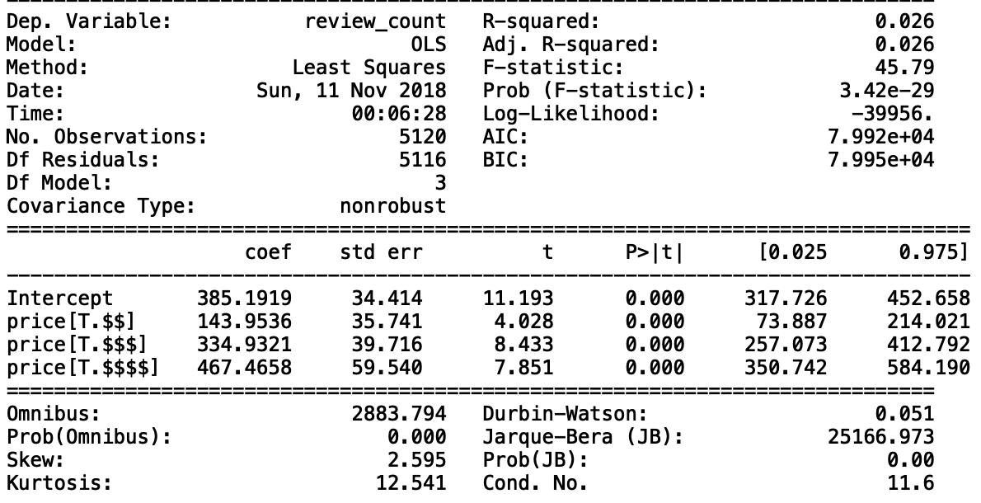

The second hypothesis is that we want to know whether the means of number of reviews have significant difference under if a restaurant offers take-out service or not. According to the result, the value of T-test is large, and the P-value is less than 0.05, which means that there is difference between a restaurant offers take-out service or not.



And the last hypothesis. We like to build a linear regression model to test if people around the restaurant are highly-educated, there is going to have more reviews for the restaurant. First of all, we can look at the linear regression scatter plot. Based on the fitted line, we can observe that it is a positive slope line which means when the rate of high-education increases, there is more chance for a restaurant to get more reviews. Next, we use a residual plot to examine the linear regression is appropriate for our data. In the residual plot, we can observe that the residuals are randomly dispersed around the horizontal axis, therefore, this linear regression model is appropriate for the data.

